Father’s Day is rapidly approaching (June 17 – to be exact!). So, we’ve made a guide to help with your shopping for dad. The days of cheesy suit ties and coffee mugs are over – as dads are becoming more “hip” and stylish.
From Kanye West to Scott Disick to Brad Pitt to David Beckham – dads are honing in on fashion, technology and lifestyle-driven products.
With that being said, please see the 2018 Father’s Day Gift Guide for the FASHION DAD, TRAVELING DAD, TECHIE DAD and FOODIE DAD! You cannot go wrong with any of these products!

Father’s Day Gifts for THE FASHION DAD

Performance Denim (Relaxed) by DUER
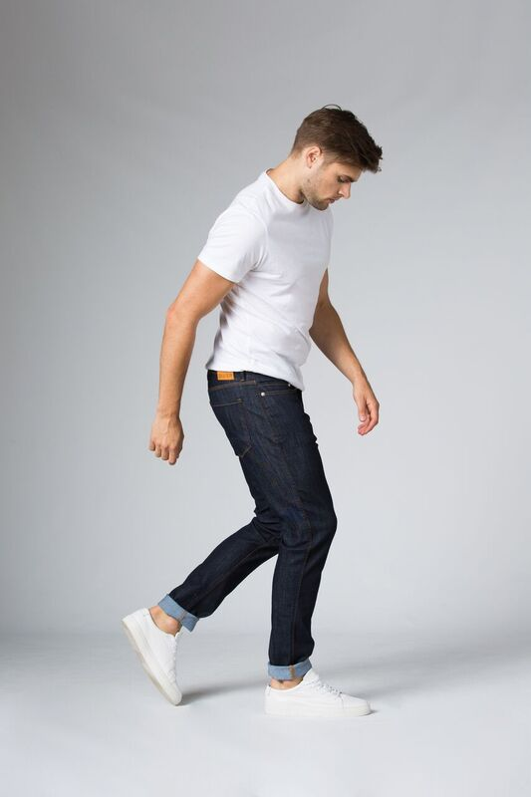

Feeling great in what you wear shouldn’t be a challenge, and Performance Denim in Heritage Rinse is the perfect piece for timeless authenticity. This relaxed-fit silhouette is an iconic wardrobe staple with refined details like reinforced contrast stitching and an antique copper button. Made from our lightweight and versatile L2X™ fabric, you can keep living your life without anything to slow you down.
Price: $129.99
Available at: https://shopduer.com

TROPICAL SWIMSHORTS by LE CLUB
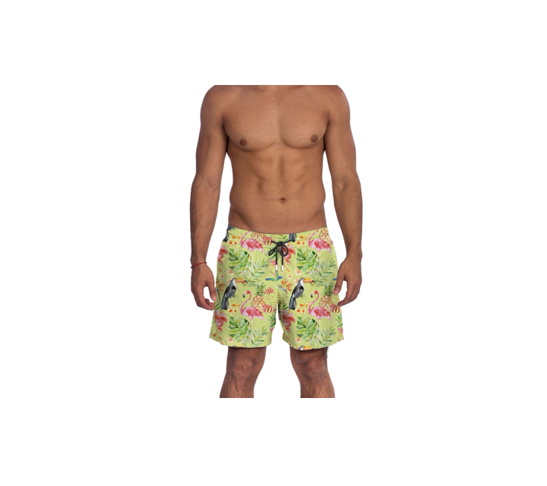

100 % Suplex/Peach Skin Touch Fabric - Quick Dry - True to Size - Tailored Fit - Elastic Waist Band with adjustable drawstring - Braided Tying Cords with Metal Embossed Logo - Fine Inner Mesh Lining - Side pockets - Back Pocket with Velcro Closure - Rear Air Ventilation Grommet - Contrast Stitching- Exclusive Design
Price: $75.00
Available at: https://www.lecluboriginal.com

SPORTFISHER BLACK – BLACK DIAL WATCH BY HOOK + GAFF WATCH COMPANY

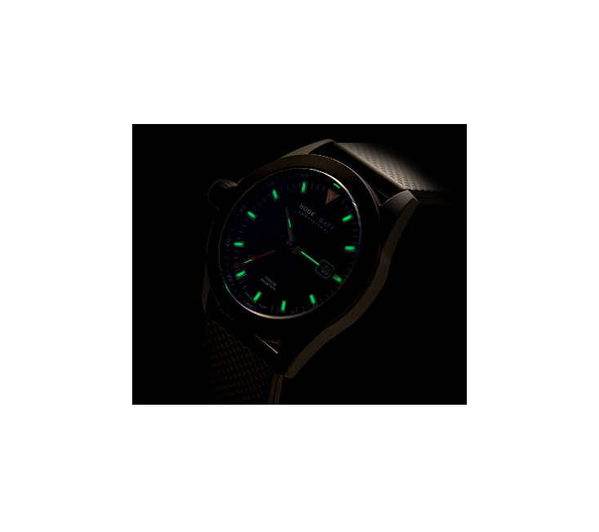

The Sportfisher Black was designed to be the ultimate watch for the hardcore angler who is out on the water during all hours of the day and night. The Sportfisher Black is Hook+Gaff’s first model to utilize 24-hour illumination tritium technology that continuously illuminates the dial’s hour markers and hands. Hook+Gaff’s specialty illumination will always shine bright to lead the way on offshore pursuits. This performance-driven timepiece is not only a necessity on the water but is handsomely crafted with a black-on-black design for show- stopping luxury.
Price: $820.00
Available at: https://hookandgaff.com

Intrepid Gent's Analog Wrist Watch BY Alfred Sung

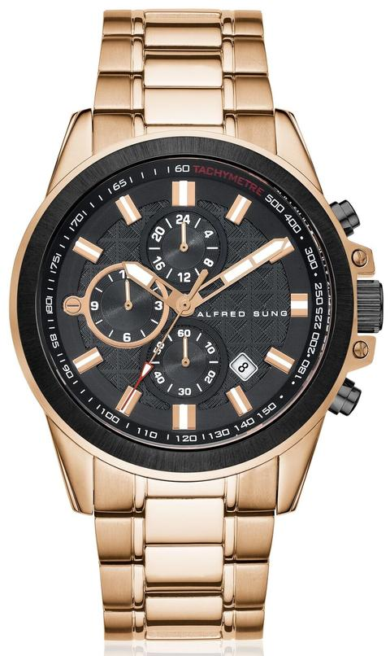

An expertly engineered wristwatch with a stainless steel case and textured dial. Featuring Japanese movement, this timepiece brings a modern aesthetic to everyday ensembles.
Price: $333.00
Available at: https://alfredsungwatches.com

Deep Blue Linen Casual Shirt BY ANTO BEVERLY HILLS

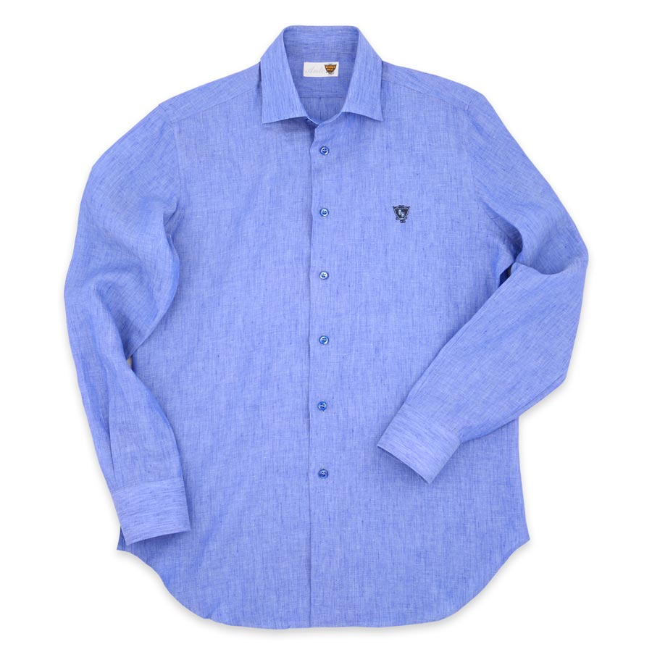

Regular Fit: Comfortable and Relaxed Body, Medium Spread Soft Collar, Extreme Round Corner Cuff, French Front, Deep Blue Mother of Pearl Buttons, Beverly Hills Signature Crest Embroidered on the Left Chest, Deep Blue Linen Fabric, 100% Linen; Italian Mill, Designed and Made in California, USA
Price: $25.00
Available at: https://www.antoshirt.com

THE STEFANO SHIRT BY S/TEAM

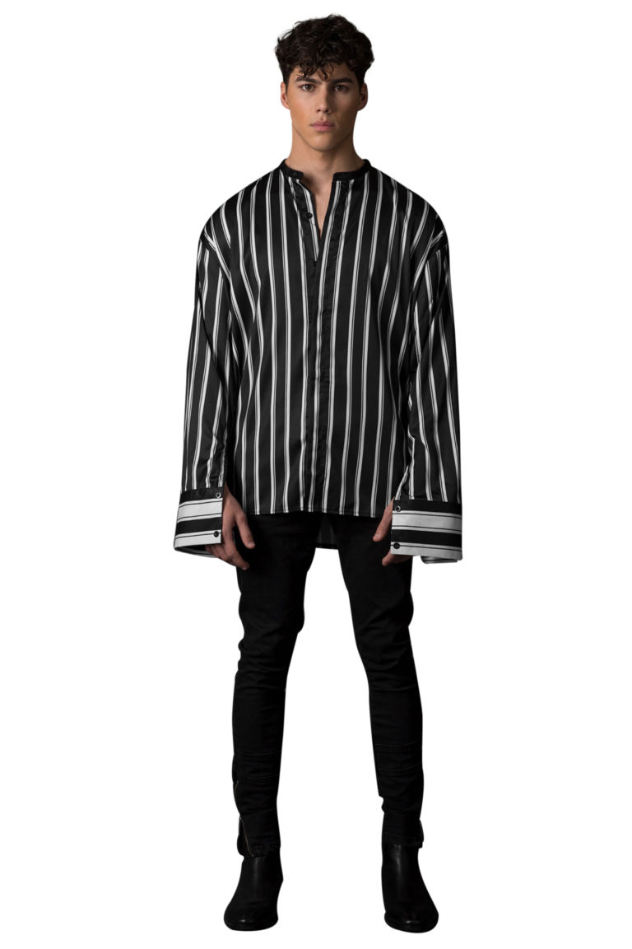

S-Team LA striped shirt with white stripes on black background, button front closure and oversized fit. Loose long sleeves with vertical opening. Concealed button placket. Fabric contrasting large cuffs with hidden button closure. Mandarin black collar. Features a below the hip length and uneven hemline.
Price: $289.00
Available at: https://www.s-team.us

SU WATCH BY TUK
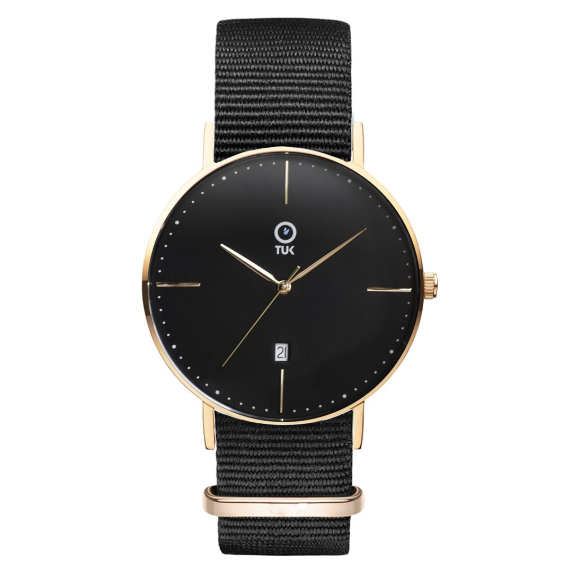

Crafted with extreme detail and durability, it's a must-have to your TUK collection. The Su transitions seamlessly from a business meeting to an afternoon happy hour with jeans and friends. Easily interchangeable so you can change it out and switch up your look with other TUK bands.
Price: $195.00
Available at: https://tukwatches.com

Halloway Sand Suede BY CROSBY SQUARE
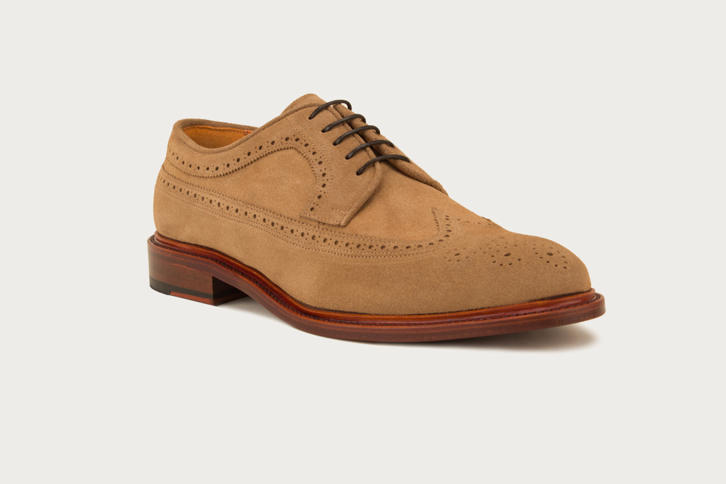

Their sturdy leather 'Holloway' derby has been crafted by hand and stitched in traditional Goodyear fashion to ensure longevity. The classic brogue perforations, luxuriously soft sand suede, blonde welt and natural leather outsole allow these lace-ups to retain an air of informality - perfect when pairing with denim.
Price: $335.00
Available at: https://www.crosbysquare.com

EMMETT SUEDE LOAFER BY JACK ROGERS

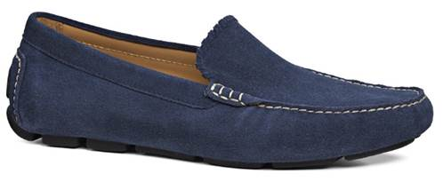

Our men’s Emmett Loafer in waterproof suede features a moc-stitched front, along with a durable rubber sole for traction and comfort. This stylish wardrobe essential is constructed to be completely waterproof and can be dressed up or dressed down to complete your everyday look.
Price: $119.00
Available at: www.jackrogersusa.com

USA Flag Denim Jacket BY BROOKLYN CLOTH
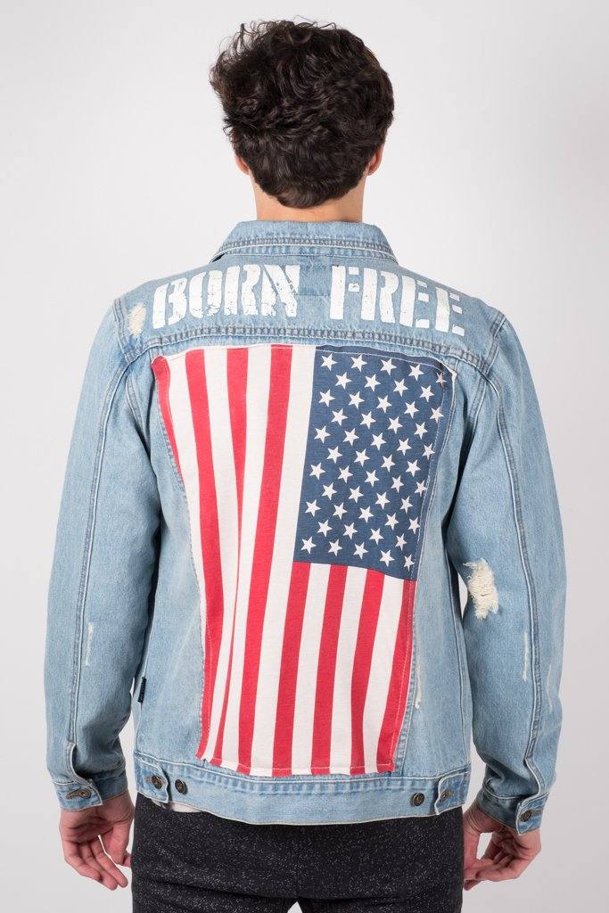
American Flag featured on the back of this light weight denim jacket. Super comfortable and casual you can dress it up or down plus has a great stretch. Great way to show your Patriotic pride. Details include printed American Flag on the back with "Born Free" at the top, metal button front, front flap pockets with buttons, embroidered patches on the front and modern fit.
Price: $52.00
Available at: https://www.brooklyncloth.com

ROWAN METALLIC LEATHER SNEAKERS BY LVL XIII
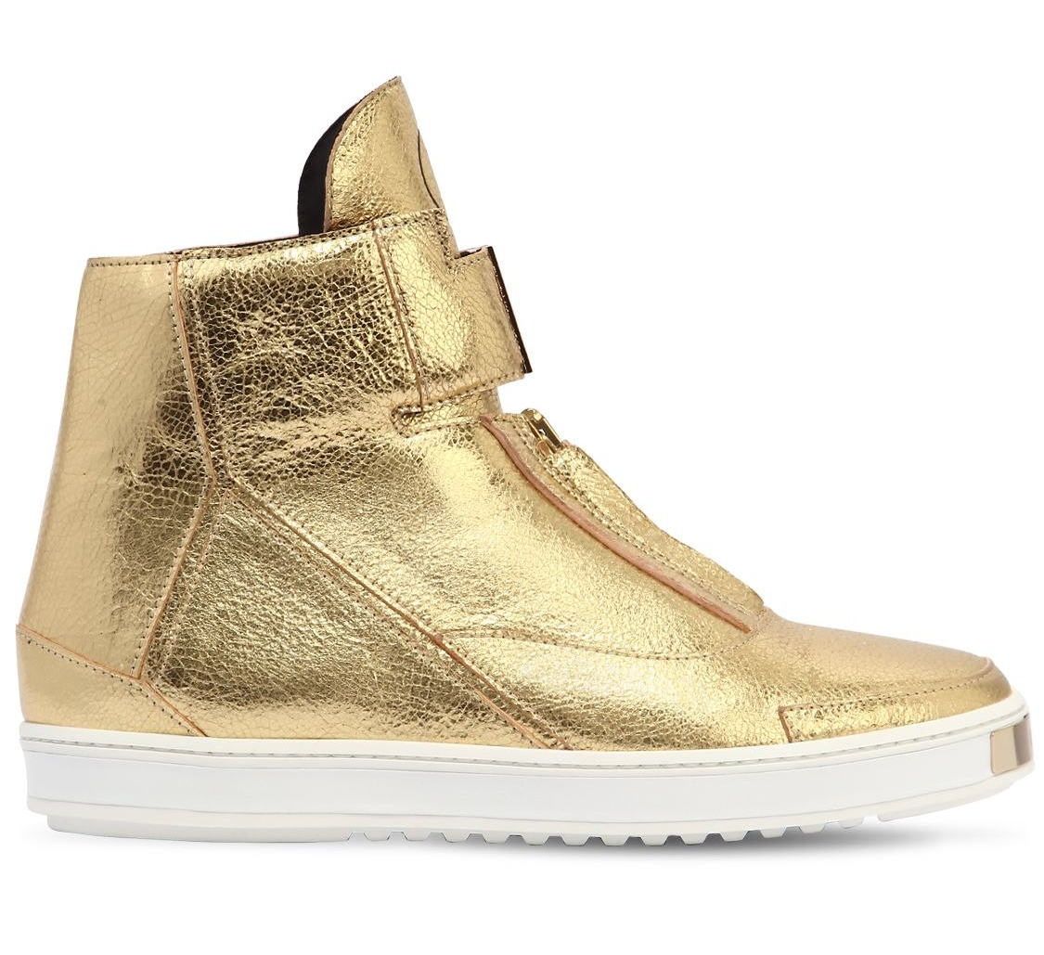

This sneaker is collaboration between LVL XIII and LUISAVIAROMA has been named the LVR Edition 19: Unexpected Emotions series, an exclusive partnership with LVLXIII and international pop/R&B artist, Jason Derulo.
Price: $1106.00
Available at: https://www.luisaviaroma.com

HERCULES MASK RING BY GUCCI


Influenced by ancient Greek and Roman culture, this exaggerated Hercules mask brings a mythical presence to the Cruise 2018 collection. In Greek and Roman mythology, Hercules is the son of Zeus.
Price: $565.00
Available at: https://www.gucci.com

SILK CADY CLASSIC BOMBER JACKET BY DSQUARED
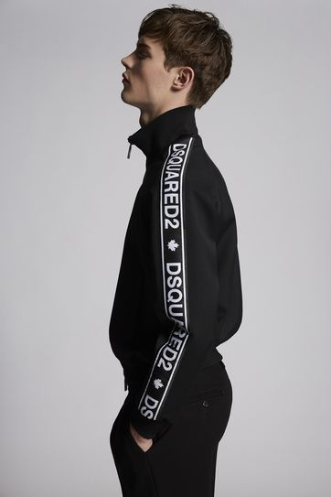
Pre-Order this item from the Fall Winter 2018 Collection; brought to you by Dean and Dan Caten.
Price: $1295.00
Available at: https://www.dsquared2.com

Paisley Silk Robe BY PAUL STUART

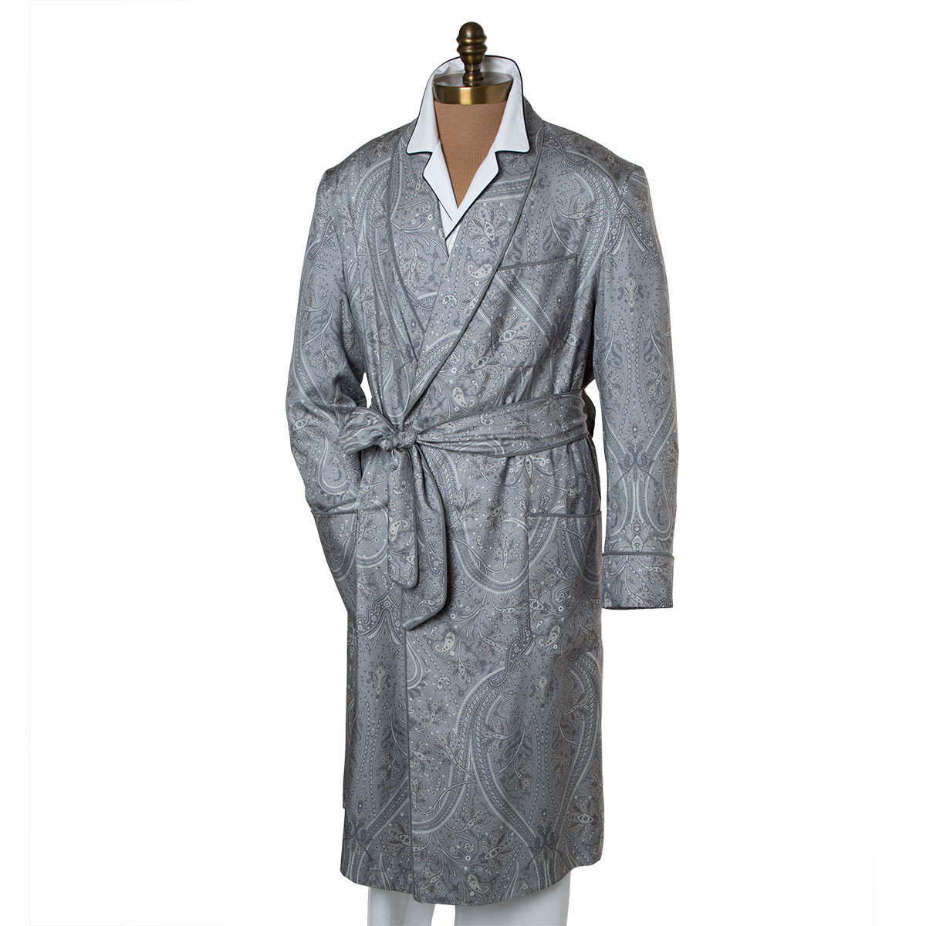

Made on Madison Collection, 100% Italian silk, Shawl collar, Contrast piping, Self belt, Side pockets, Made on Madison Avenue, Dry clean
Price: $1195.00
Available at: https://www.paulstuart.com

Father’s Day Gifts for THE TRAVELING DAD

Horizon 70 ROLLING SUITCASE BY LOUIS VUITTON
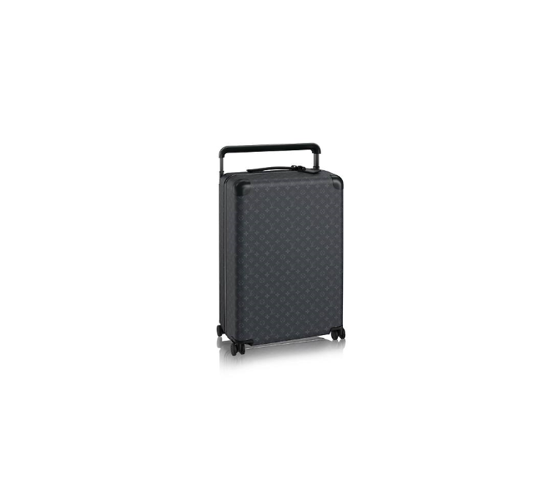

The fruit of a remarkable collaboration between Louis Vuitton and Marc Newson, the most influential industrial designer of his generation, this rolling luggage for the 21st century traveller is fashioned in iconic canvas with an aluminum wide trolley system.
Price: $3900.00
Available at: https://us.louisvuitton.com

Saffiano Leather Briefcase BY BUGATCHI
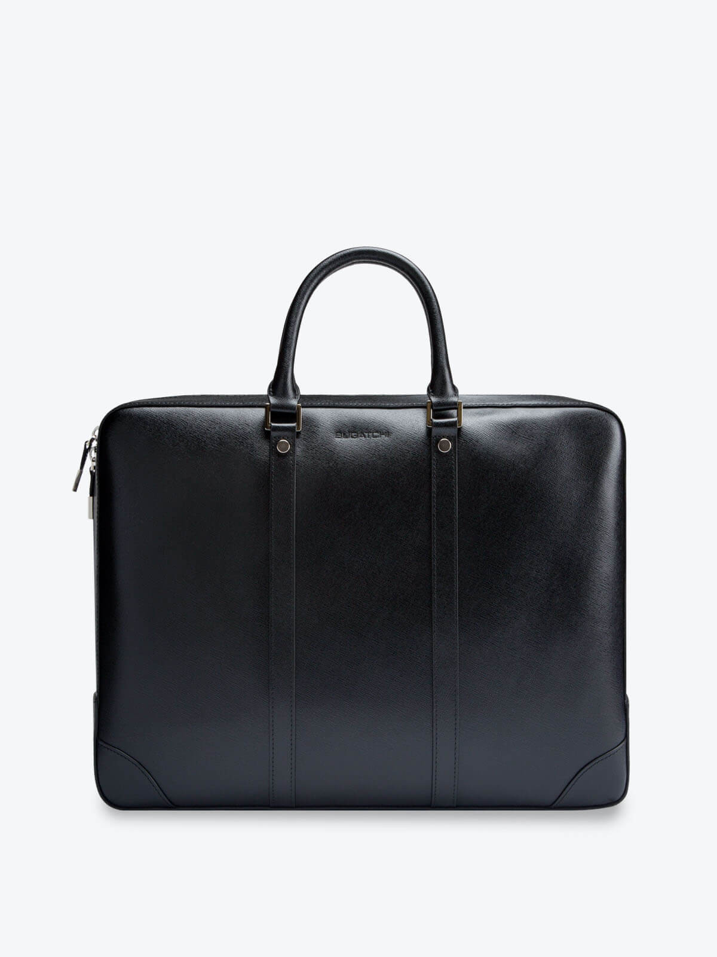

Saffiano leather briefcase features two way top zipper closure. Interior has one zipper pocket, two slip pocket, pen holders and a padded computer pocket. Silver tone hardware, logo engraved zipper pulls, ottoman lining and tonal stitching.
Price: $237.00
Available at: https://www.bugatchi.com

ANDIAMO CLASSICO BY ANDIAMO
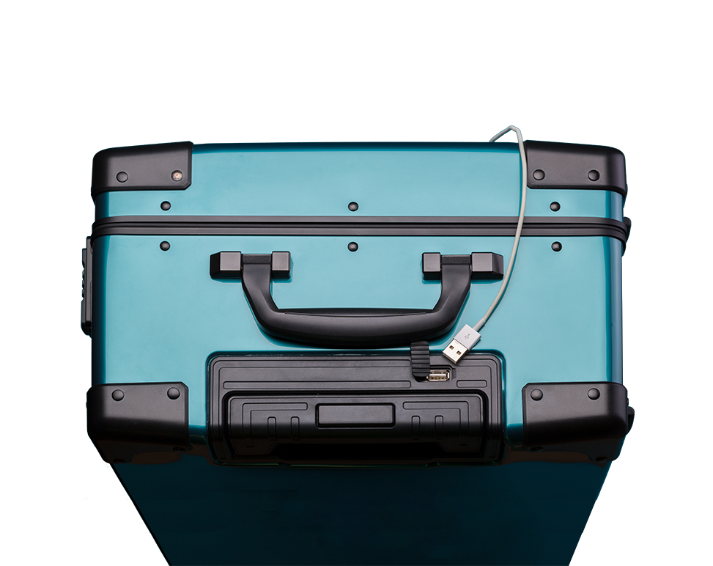

The Andiamo Classico is designed with classical aesthetics and modern travel needs in mind. The beautiful high gloss finish and silent spinner wheels let you glide effortlessly through the airport and be the point of envy.
Price: $299.00
Available at: https://www.andiamoluggage.com

SILVER INTERLOCKING G MONEY CLIP BY GUCCI
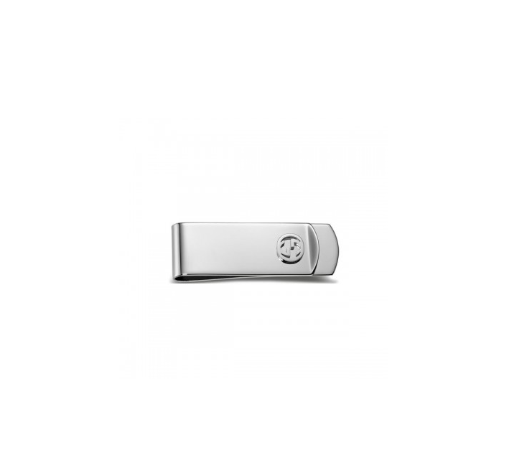
This sleek and slim money clip is from the Gucci Icon collection. Crafted in sterling silver with a palladium rhodium finish, it features the brand's interlocking G motif. This Gucci money clip makes a great gift to give and receive; it will be found in the pockets of well-dressed men the world over! ITEM SOLD AT J.R. DUNN JEWELERS!
Price: $275.00
Available: https://jrdunn.com
SUMMER SERUM COMPLEX BY REPLETE SKINCARE

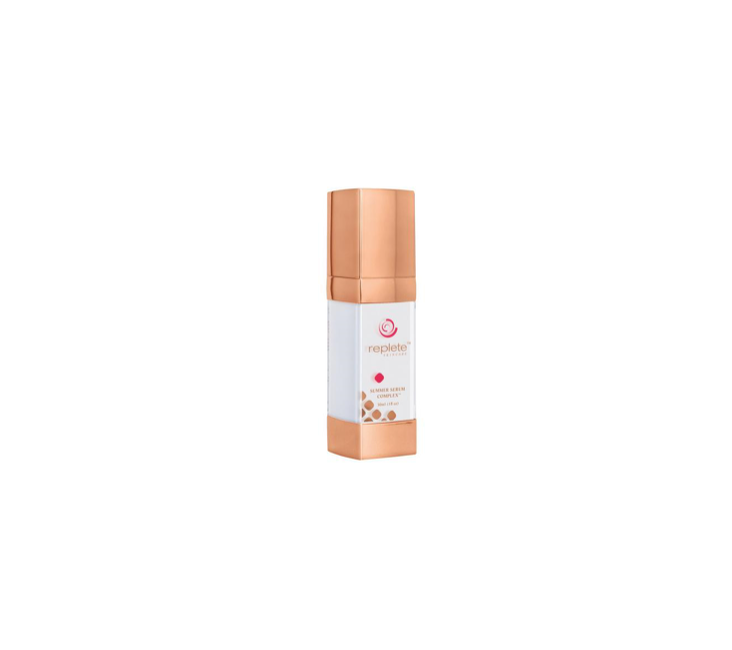

Summer Serum Complex™ is one of our Seasonal Skincare products that is highly concentrated with 39.75% active ingredients. 100% of the product is usable by the skin and will absorb without leaving any residue if following the suggested amount. With proper use should last for three months.
Price: $345.00
Available at: http://www.repleteskincare.com

Father’s Day Gifts for THE TECHIE DAD

CAR DASHCAM by COBY
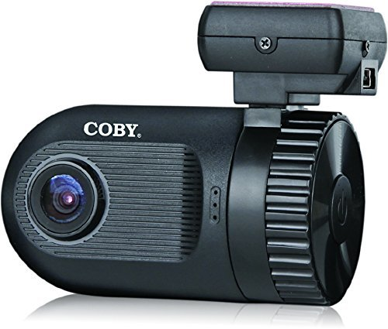
Coby’s Car Dash Cam is a one of a kind camera designed for your dashboard. This cam is easy to use and setup. Its automatic On/OFF feature allows for easy use. Its main feature is the 1.5 TFT Screen. This cam comes with 4x Digital Zoom, GPS Logger including time & date stamp. Its G-sensor collision detection is great for sudden breaking, acceleration and impact. This cam supports up to 32GB SD card. This camera is sleek and user friendly
Price: 140.00
AVAILABLE THROUGH AMAZON here: https://www.amazon.com/Coby-Tailgate-Bluetooth-Speaker-Subwoofer/dp/B074P7MQGC/ref=sr_1_1?ie=UTF8&qid=1516723978&sr=8-1&keywords=coby+tailgate+speaker

SLEEPPHONES
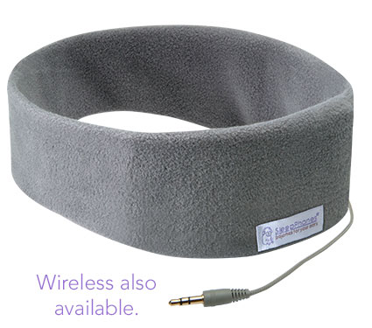

SleepPhones® are fully padded with nothing sticking into the ears and are comfortable even for side sleepers.
The luxuriously soft headband contains thin removable speakers to play any type of music, audiobooks, meditation, white noise, or talk radio. It plugs into any audio device with the standard 3.5mm (1/8 inch) headphone jack.
Price: $149.95
Available here: https://www.sleepphones.com

360 CAMERA By RYLO
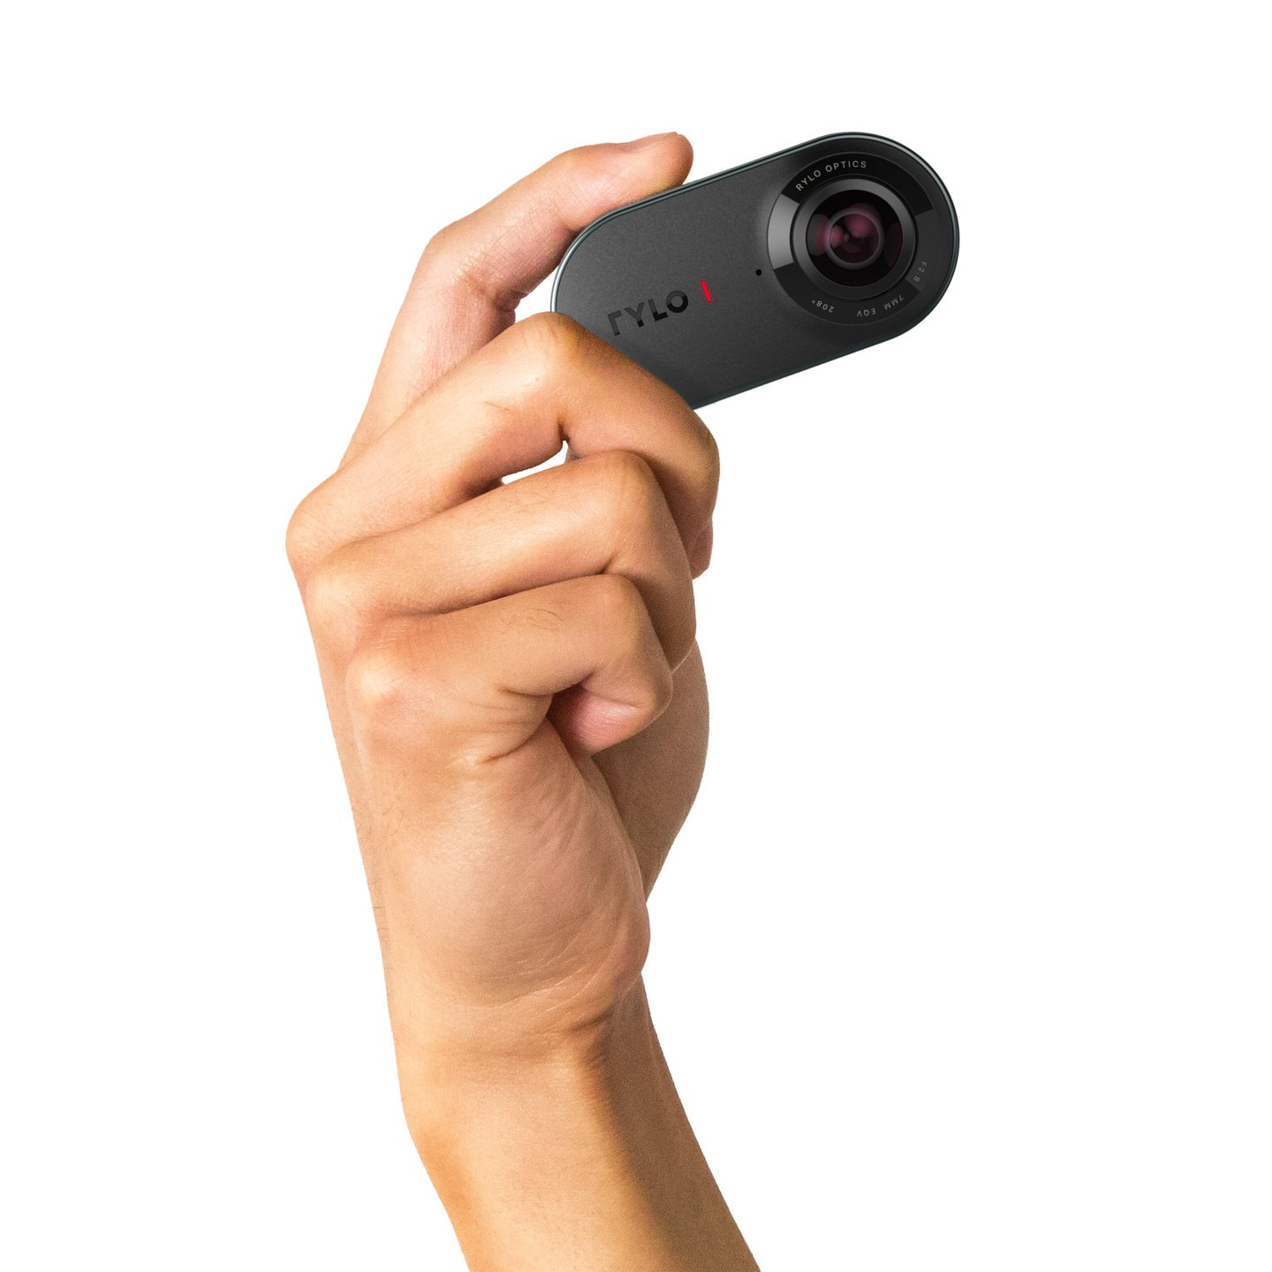
From a child’s first goal at their soccer game to biking and swimming at the lake, Rylo’s innovative 360 degree capabilities and in-app editing ensure you won’t miss a moment, no matter where you point the camera.
Price: $499
Available here: https://www.rylo.com

GO FISH CAM

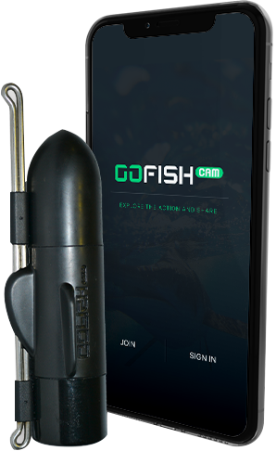

The Most Popular Underwater Wireless Fishing Camera and Mobile App. GoFish Cam an HD wireless fishing camera that sits on your fishing line, without disrupting your fishing tackle, and works with a mobile app so that you can see what's happening underwater while fishing!
Price: $239.99
Available here: https://gofishcam.com/

Swagtron Swagcycle PRO
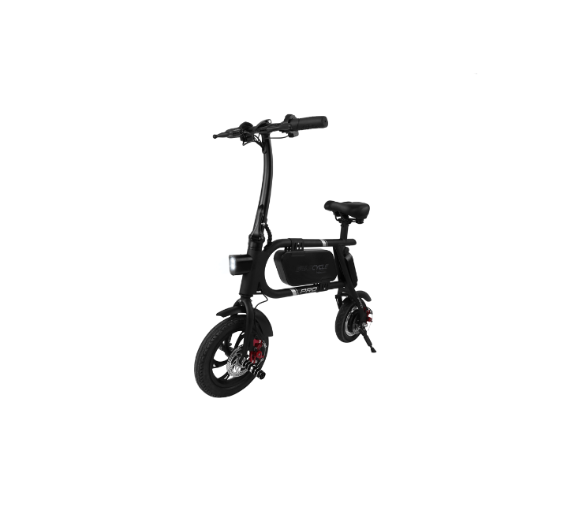

The Swagcycle PRO is a compact pedal-less scooter bike—perhaps the smallest e-bike on the market—but boasts a new iOS/Android app that tracks speed, battery life, GPS routes and more. The PRO also gets a powerful 350-watt motor for a top speed of 18 miles per hour, and an extended battery range of 15.5 miles.
The Swagcycle PRO features an LED headlight, dual disc brakes and a UL certified 36V Li battery that includes a USB charging port for devices mated to its lightweight aluminum frame. A folding stem and handlebar make it a smartly compact folding electric bike that can be easily stowed in the home or office, the back of a vehicle, even carried on public transportation like trains and buses.
Price: $600.00
Available here: https://swagtron.com/

My Q SMART GARAGE HUB BY CHAMBERLAIN
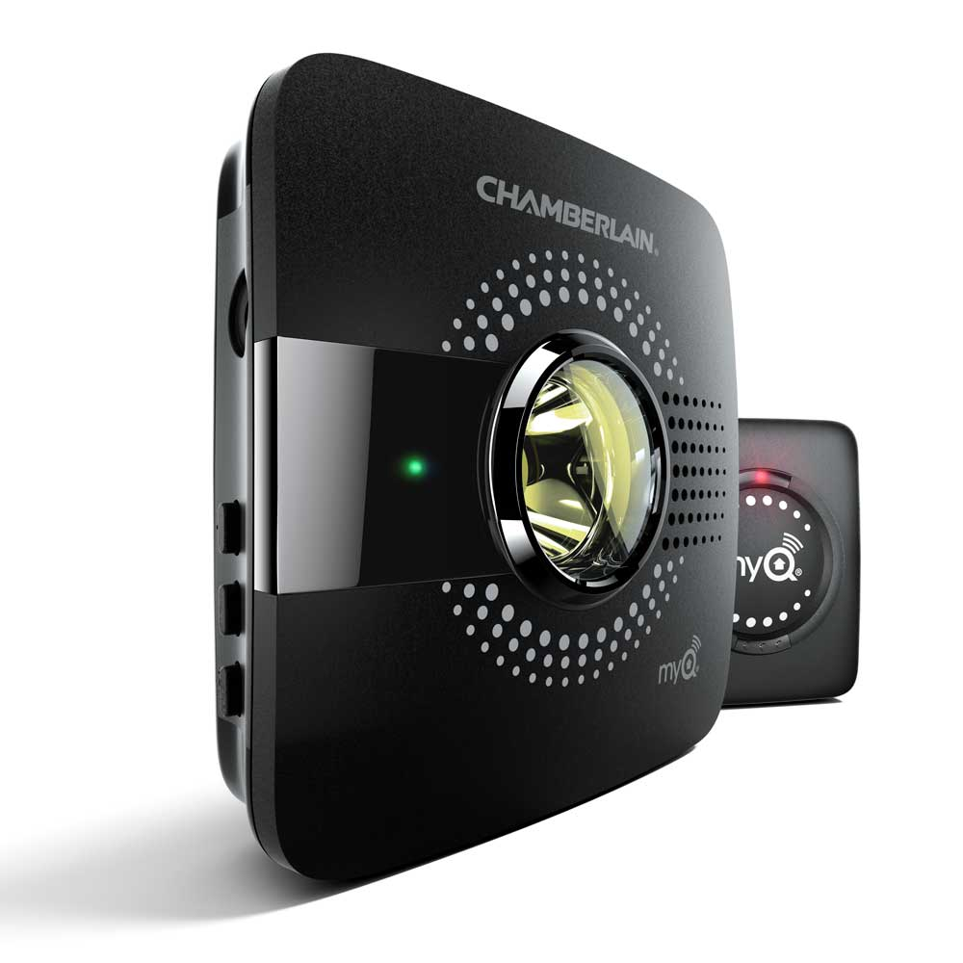

The MyQ Smart Garage Hub adds smartphone control to most major garage door opener brands with photo eyes (see compatibility section below for details). Get peace of mind knowing the main access point to your home is secure. Check the status or control your garage door from anywhere so you never have to worry if you left your garage door open.
Price: $79.99
Available here: https://www.chamberlain.com

IS-4000 InstaShiatsu+ Foot Massager With Heat BY truMedic

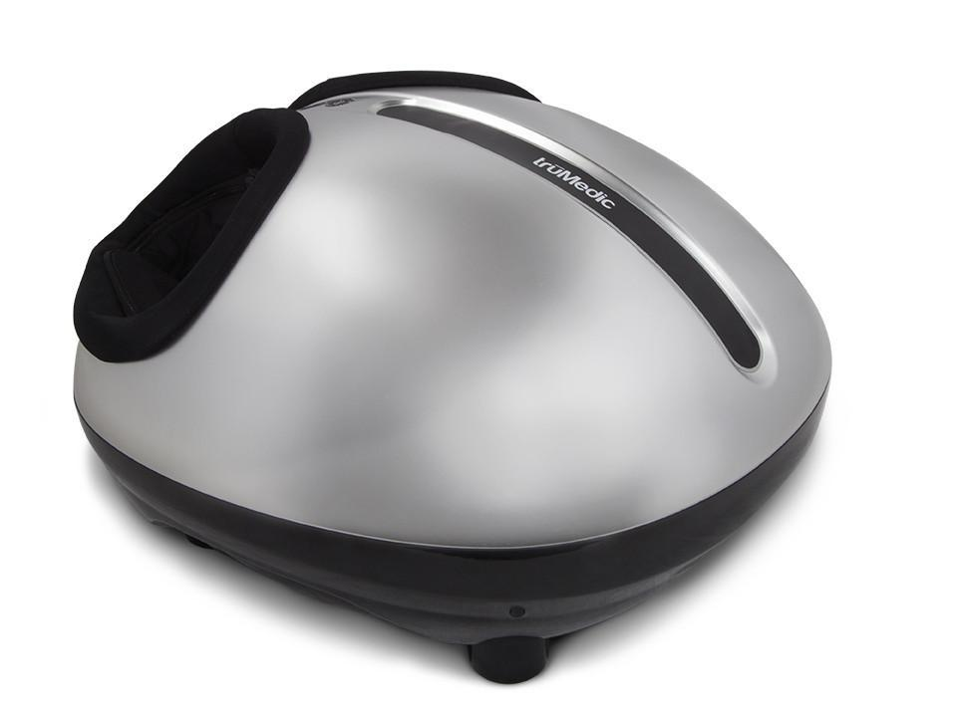

Perfect to give your hardworking father a wonderful, deep-kneading shiatsu massage with heat that they can use anytime, anyplace. The rechargeable InstaShiatsu+ also feels excellent on calves, thighs, or lower back.
Price: $399.97
Available here: https://www.chamberlain.com

THE SUPERCHARGER BIKE BY Riese & Müller

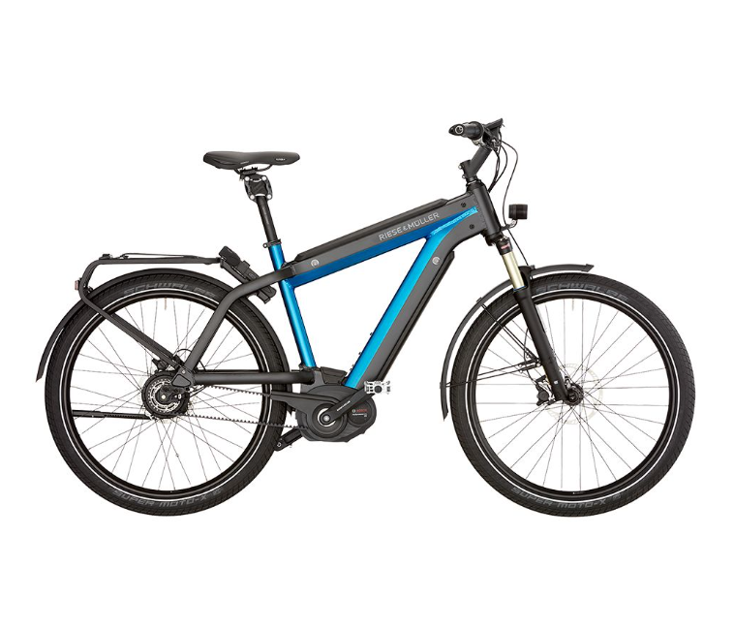

The long-distance runner of E-Bikes.
The Supercharger does not brag about its inner values, it simply has them. Thanks to the full integration of up to two Bosch PowerTube batteries in the frame and the coordinated colour scheme, the whole bike has a very sporty look and appears to have been cast in one piece. When it comes to range, with its battery capacity of up to 1,000 Wh it delivers outstanding results on the road. The unique ride and comfort make every mile an experience. The Supercharger covers seemingly endless distances without pausing to recharge.
Price: Starts at $5,500
Available at: https://www.r-m.de/en-us/

PETCUBE BITES BY PETCUBE
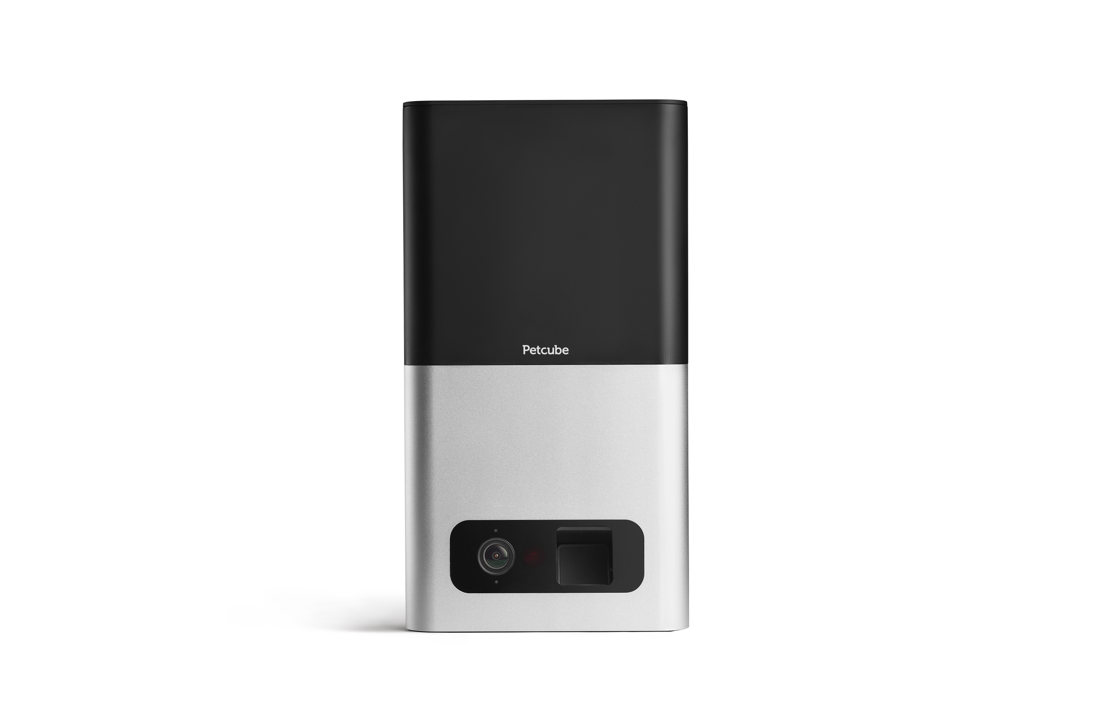

Petcube Bites is an interactive pet cam that allows pet owners to treat and reward their pets on-the-go through their smartphone. Petcube Bites also comes with advanced camera features, including 1080p HD video, 138°-degree wide angle lens, 24/7 video recording, 3x digital zoom, two-way audio, sound and motion alerts, and night vision. It also integrates with Amazon Alexa and Amazon Dash Replenishment Service for automatic treat reordering when supplies run low.
Price: Starts at $249.00
Available at: https://petcube.com
Also: Amazon, Best Buy, Bed Bath & Beyond, Petco and other major retailers.

MIGHTY



Mighty is the music player for the streaming era. Mighty was built for music lovers on-the-go (travelers/commuters, outdoor enthusiasts, runners/gym goers, kids, etc.) and is a must have for any dad: Everyone listens to streaming music now (vs downloading) and Spotify is the leader. No more running or working out with bulky smartphones (in your hand or awkwardly on your arm). No more cracked screens.
Price: $85.99
Available at: https://bemighty.com/

Father’s Day Gifts for THE FOODIE DAD
KAMADO CERAMIC CHARCOAL GRILL BY GRILLA GRILLS

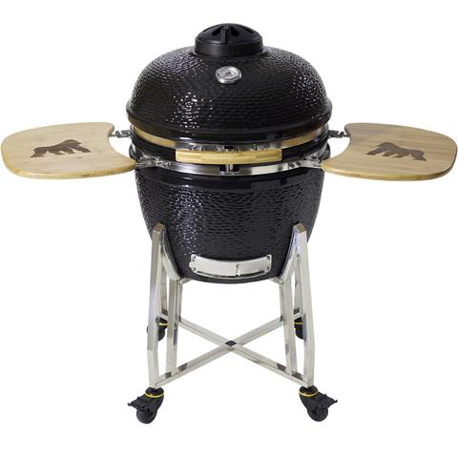
Grilla Grills Kong is a ceramic kamado grill made of heavy-duty ceramic for grilling, smoking, baking and roasting. Uses lump charcoal for excellent flavor. Retains heat and moisture for extended cooking. Ideal for all BBQ meals. Dome temperature gauge. Adjustable vent. The large, stainless steel cooking grates are easily accessible from the sides and are split for direct and indirect cooking. Twin work surfaces fold down for easy storage. Sure-latch lid. EZ glide wheels. High-gloss finish.
Price: $799.99
Available at: https://store.grillagrills.com/

TRINCHERO NAPA VALLEY 2013 BRV CABERNET SAUVIGNON

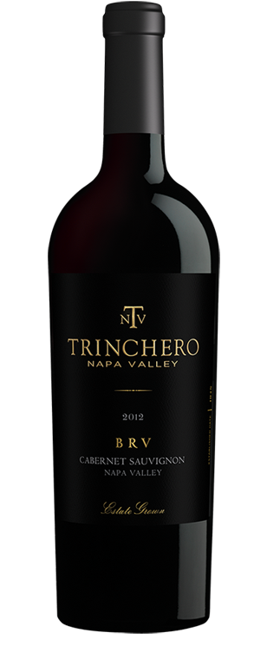
The Cabernet Sauvignon makes it all about family. Honoring the second generation of one of Napa Valley’s pioneering families, BRV offers something truly notable with an elegantly balanced, yet rich and velvety taste profile. Dad’s definitely worth the splurge when it comes to this special wine.
Price: $80.00
Available at: http://www.trincheronapavalley.com

Model Two Elite Pro Wine System BY CORAVIN
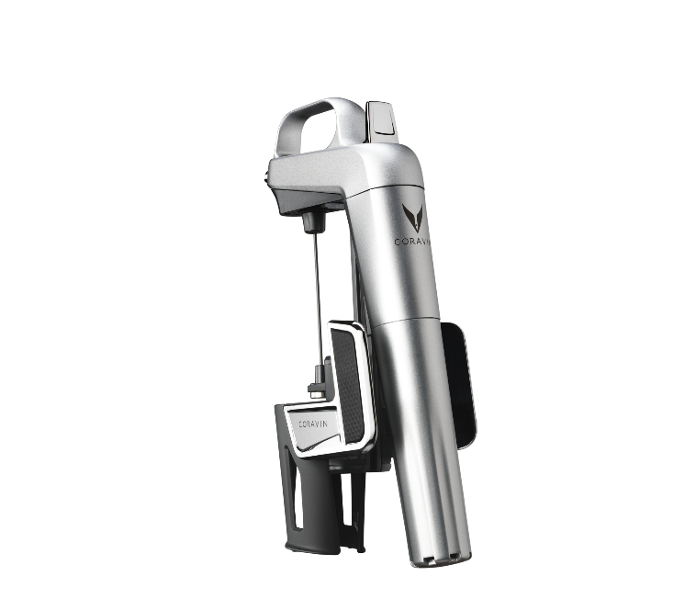
Coravin Model Two Elite Pro is the ultimate way for stylish and savvy wine connoisseurs to savor a perfect glass of wine without pulling the cork. The Model Two Elite Pro possesses a perfect balance of luxury and technology and offers the opportunity to choose the color that better fits into your space. This ultimate Coravin experience comes complete with an elegant classic base to showcase your System, a stylish carry case to bring your Coravin experience with you anywhere, and four Coravin Capsules to comfortably pour 60 epic glasses of wine.
Price: $399.95
Available: http://www.coravin.com
Modern Charcoal Tabletop Grill by Curonian Deco

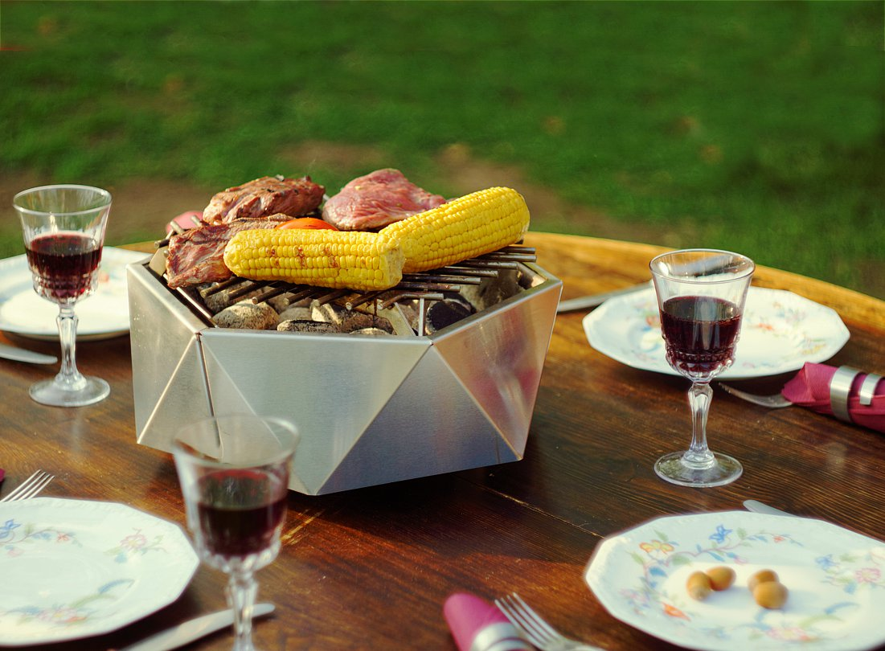

Weighs just 17 pounds (portable);
Once lit, it stays hot for up to 1.5 hours. You can use either charcoal or wood chips to heat it. This opens even more possibilities of what you can grill. From fish, to steak to s’mores- it’s all doable;
Price: $249.00
Available at: http://www.curonian.com

E8 Chrome BY JURA

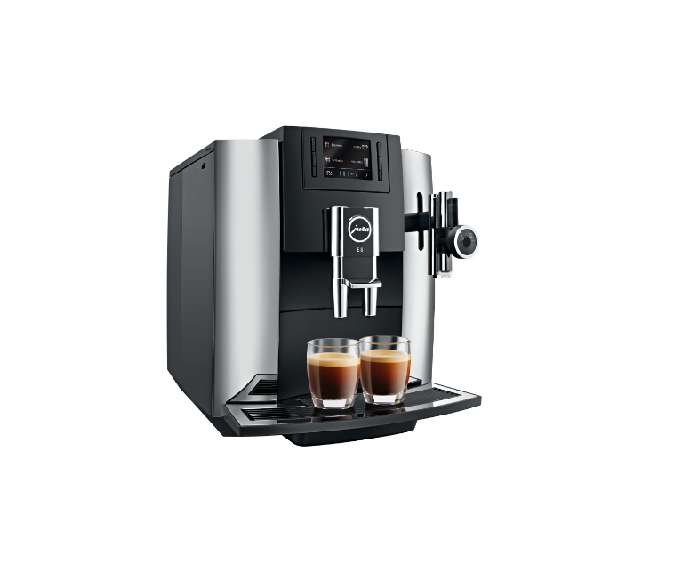

URA’s new E line is revolutionizing the enjoyment of coffee in every aspect. The espresso brewing process has been 100 % perfected. The Pulse Extraction Process (P.E.P.®) is the only process of its kind in the world. It optimizes the extraction time and guarantees the very best aroma even for short specialty coffees.

Price: $1,999.00
Available at: https://www.shopjura.com

